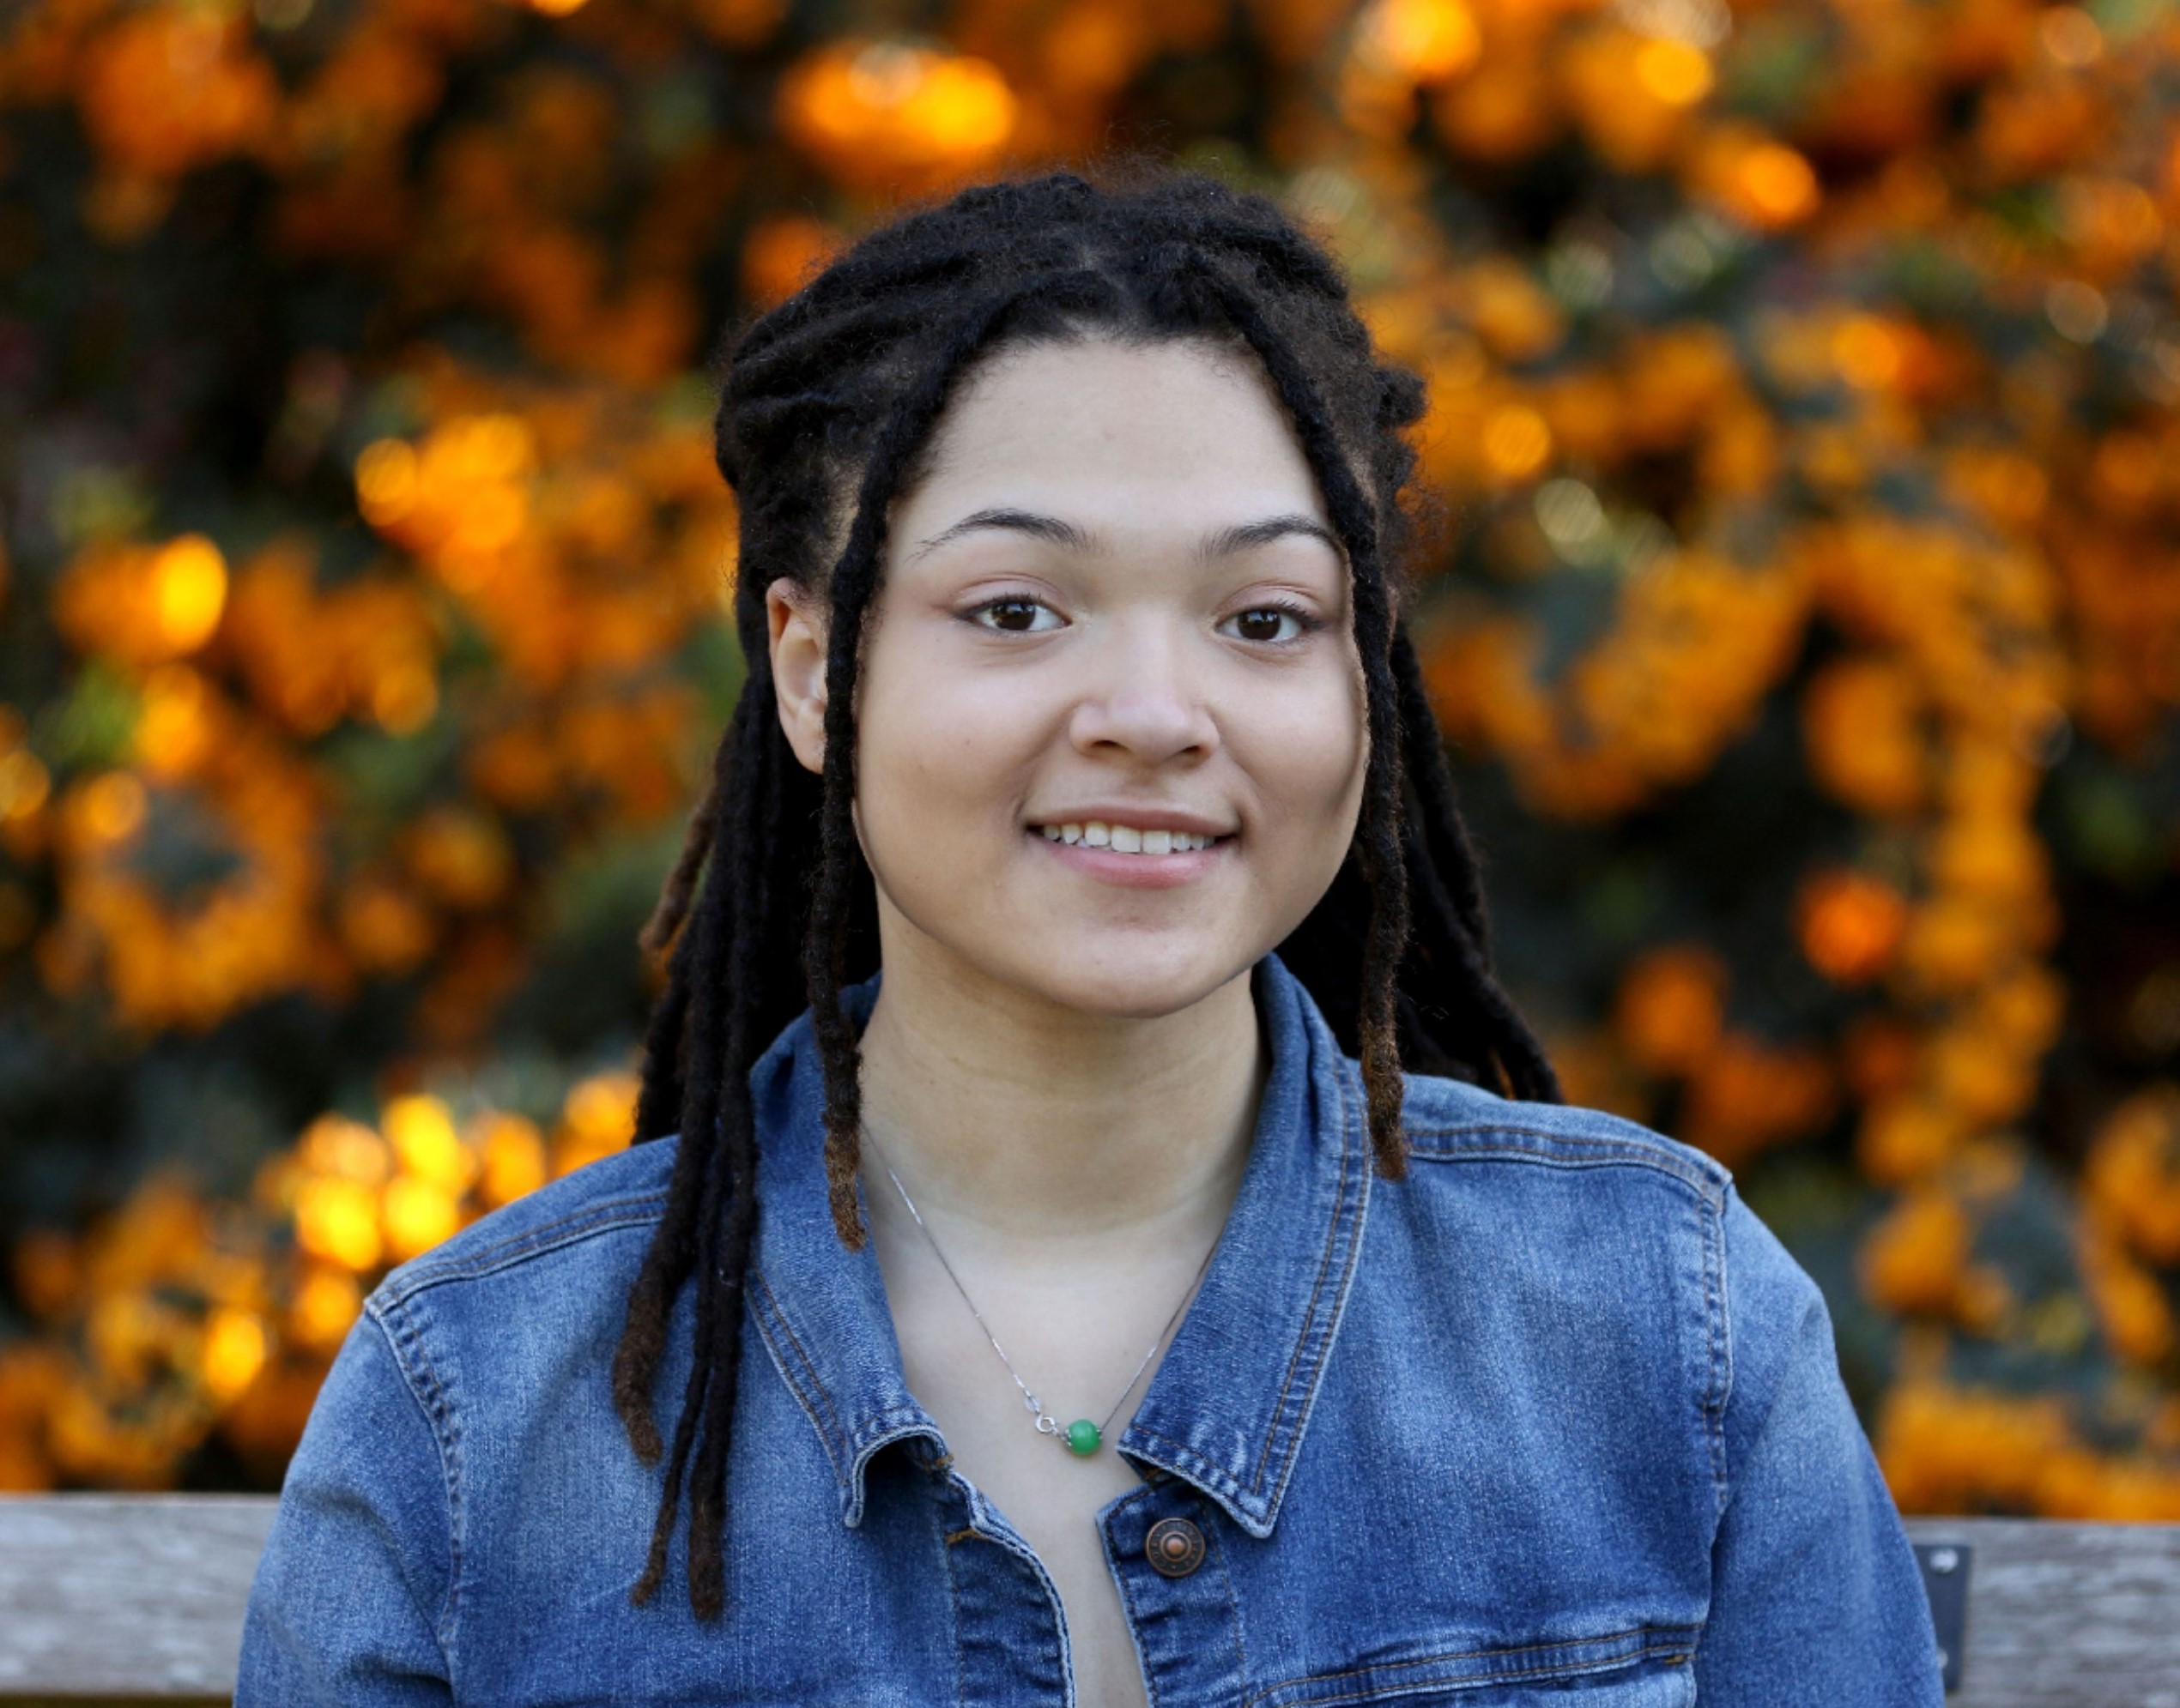  I graduated from Kennedy Catholic high school and will attend the University of Washington in the fall. I have been involved with the GEMS since my freshman year and prior to that, I joined the Dr. Betty Shabazz Delta Academy while in middle school.  It has been such a blessing being around a strong group of young, Black, and gifted female minds. Over the years, we have had several discussions about what it means to be a Black woman in the Pacific Northwest, cultural appropriation, mental health, self-improvement, and more. I am more introverted than I would like to be, but this program helped me see the value in my opinions and how beneficial it would be to share them. The GEMS helped me overcome fears of self-doubt and anxiety and after every meeting I was left feeling inspired, educated, and hopeful for our future discussions. I cannot thank the GEMS program and my mentors enough.  Nia Kendall  2020 graduating GEM  Member since 2018 | The Seattle Alumnae Chapter of Delta Sigma Theta Sorority, Inc. has served King, Kitsap, & Snohomish Counties since 1933.  2019-2020 GEMS  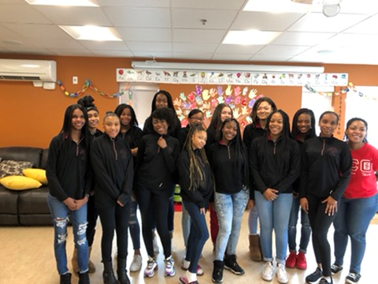  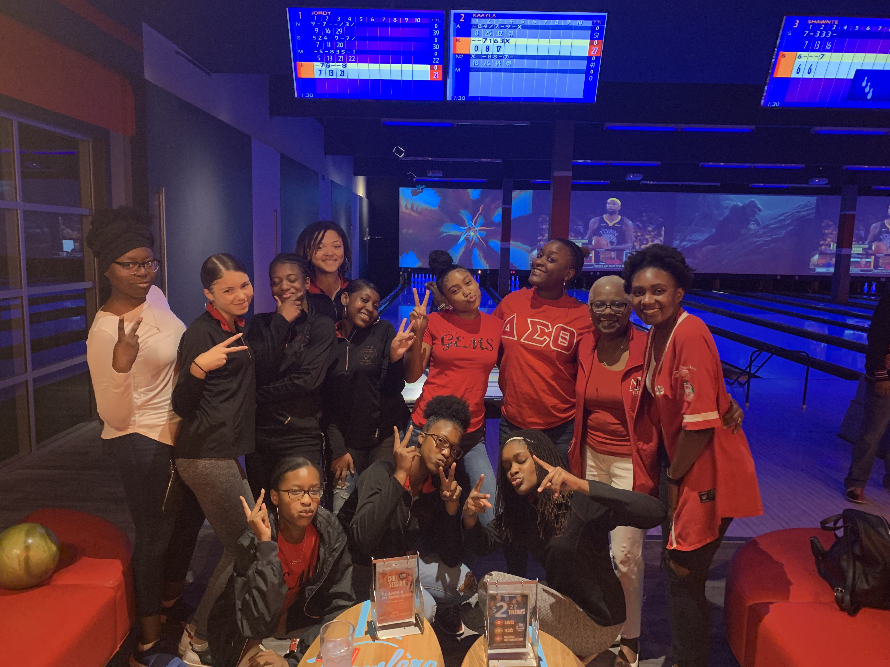 |  | G.E.M.S.  Growing and Empowering  Myself Successfully  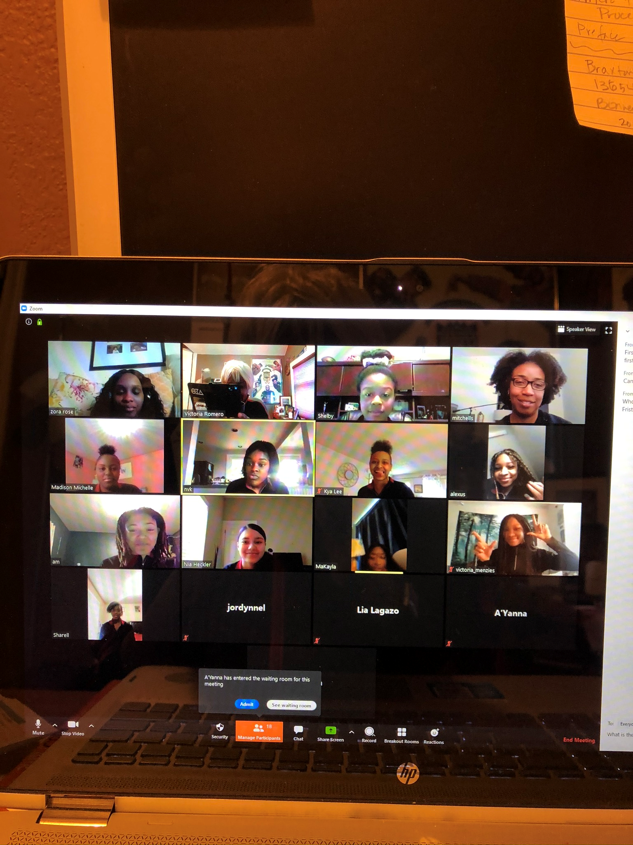  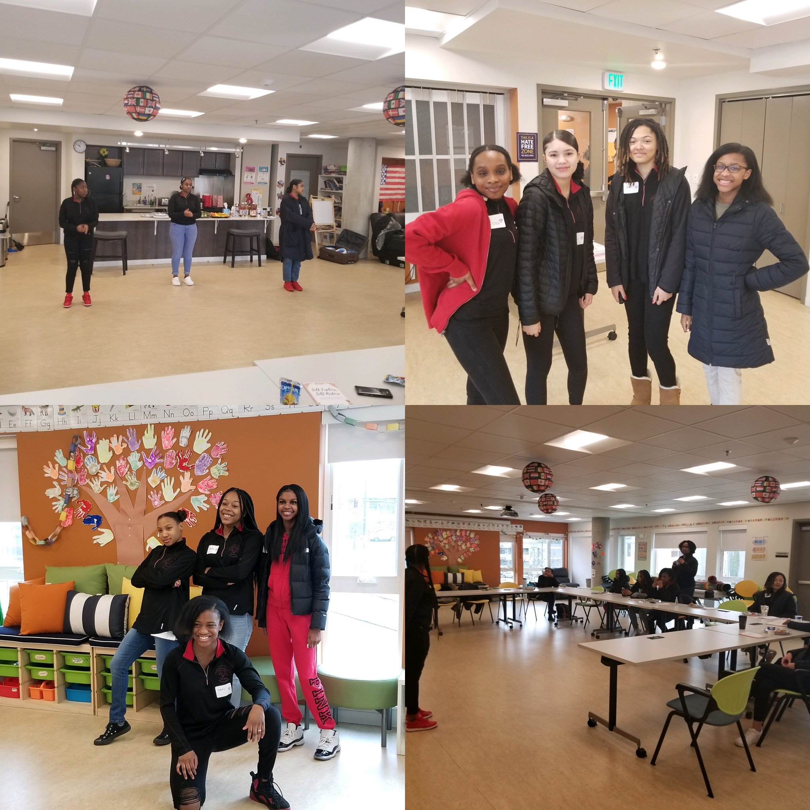  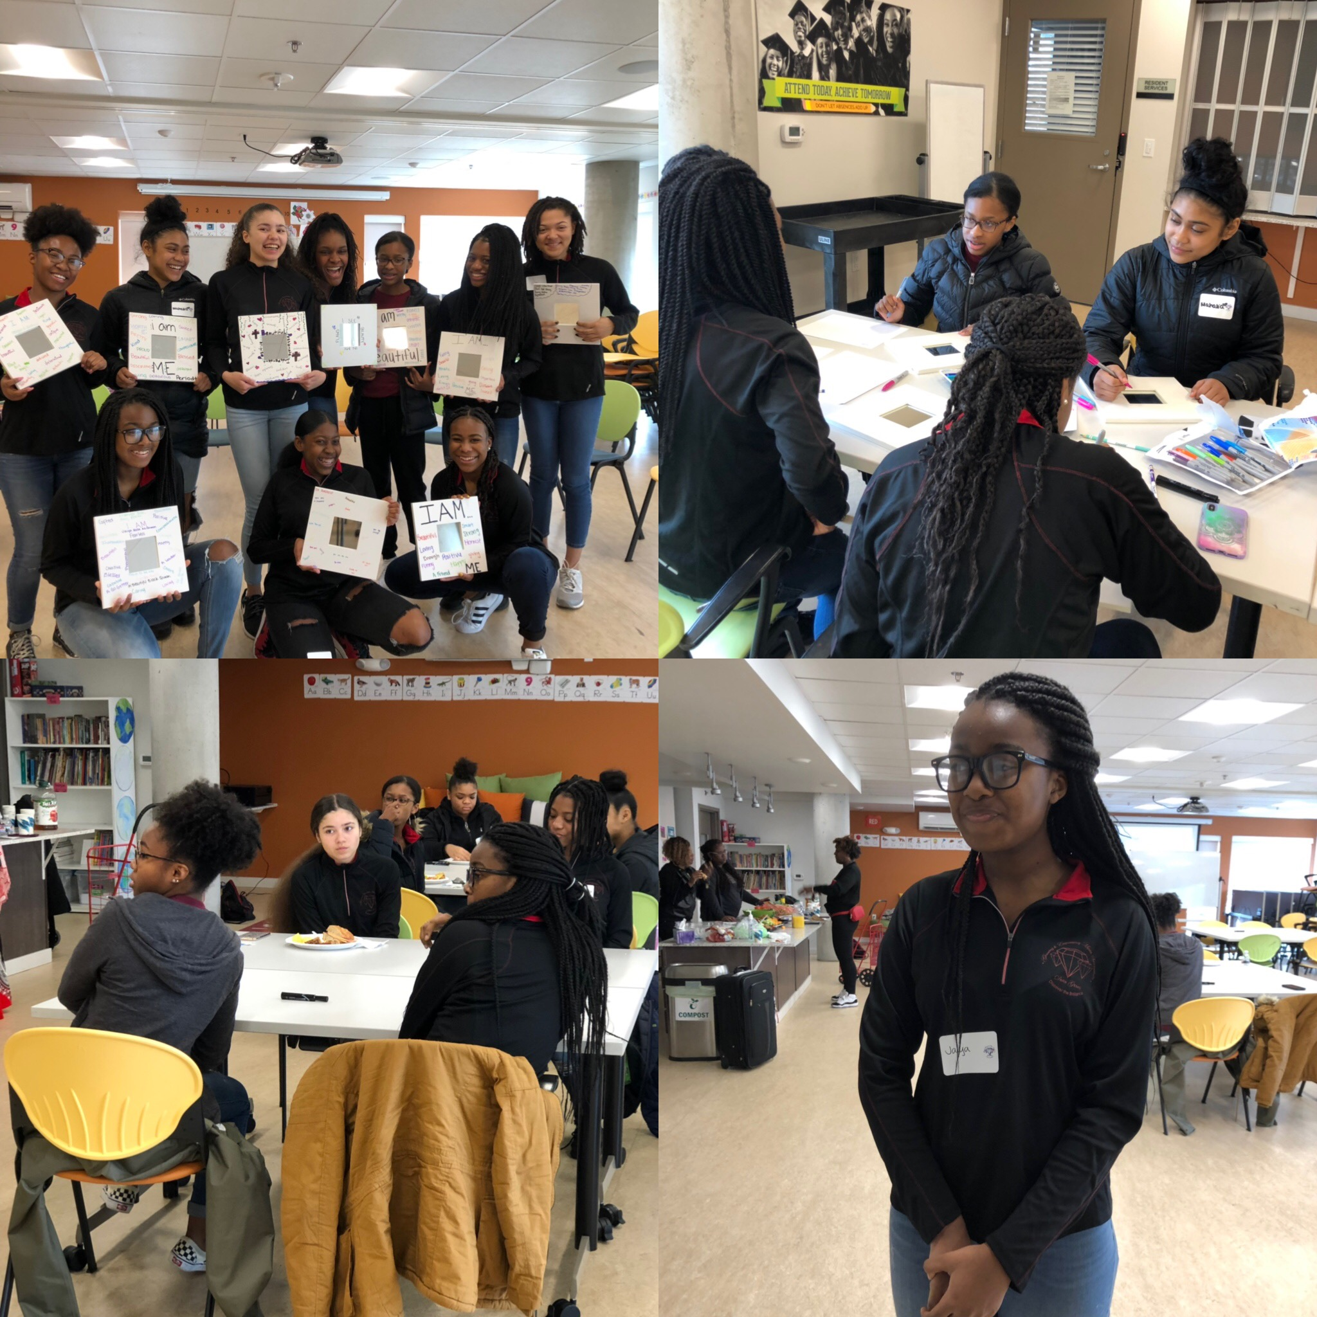  2017-19 GEMS
Alexandria ‘Alex’ Myers
Class of 2021

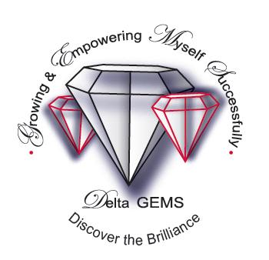The Dr. Jean L. Noble Delta G.E.M.S. supports young girls in 9th-12th grades  What are the goals of Delta Noble G.E.M.S.?  -To instill in our girls the need to excel academically  -To provide tools that will enable our girls to care for their mental, physical and emotional well-being  · To assist our girls in proper goal setting and planning for their futures—high school and beyond  · To create compassionate, caring and community-minded citizens | Delta Sigma Theta Sorority, Inc.  Founded January 13, 1913  Howard University- WA D.C.  Non-profit public service organization  1000 chapters in USA, Bahamas, Bermuda, England, Germany, Jamaica, Japan, Korea, Liberia, Nigeria, Virgin Is  Focus: 5 Point Program Thrust  Political Awareness & Involvement  International Awareness & Involvement  Educational Development  Economic Development  Physical & Mental Health  The members of the Seattle Alumnae Chapter pay ALL expenses. There are no extra charges for families. | Program Details  Eligibility: For 9th-12th grades girls  Sessions:  3rd Saturdays 10-noon  October-June  Location TBA  ****************************  G.E.M.S. program also include  Lunch  Black History mini-lessons  Theater or Movie Excursions  Exposure to women who are scientists, physicians, engineers, lawyers, managers and business owners  Open to all ethnicities & religious groups  Perform public service project  Seattle Alumnae Chapter  Delta Sigma Theta Sorority, Inc  PO Box 28046 Seattle 98118  info@seattledeltas.org  Applications @ www.seattledeltas.org  Beginning Aug 1-Sept 13

