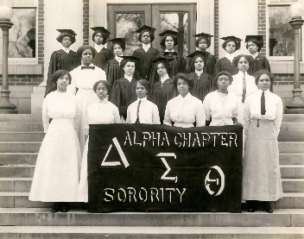

Delta Sigma Theta Sorority, Inc. was founded on the campus of Howard University on January 13, 1913. It is an international public service organization composed of college-educated women of African American descent. The Seattle Alumnae Chapter is one of a thousand chapters around the world supporting their local communities. In 1933, the Alpha Omicron Chapter was chartered. It was composed of women at the undergraduate and graduate levels. Ms. Tessie Miller became the first president of a Delta chapter in the Pacific NW. Today, AO is a collegiate chapter located on the campus of the University of Washington. Seattle Alumnae is now a citywide chapter of college graduates. Our service areas are King, Kitsap and Snohomish Counties. The Tessie Miller Scholarship carries on the legacy of scholastic achievement by providing financial assistance to eligible students enrolled in AP classes.

ELIGIBILITY FOR THE TESSIE MILLER SCHOLARSHIP

The Tessie Miller Scholarship will award up to $100 to an individual student to cover the costs for Advanced Placement classes. The Tessie Miller scholarship can be awarded to one single school to cover the cost of up to three (3) students taking one class each totaling no more than $300 each year. This scholarship is open to high school students attending schools in King, Kitsap and Snohomish Counties.

Applicants must:
- Identify as Black, Indigenous, Person of Color
- Taking AP class(es) not to exceed $100 per applicant.
- Expresses a financial need and does not qualify through other financial resources
- Sign media release, submit photograph and brief biography to be displayed on Seattle Alumnae’s and Delta Sigma Theta’s social media. If student is under 18 years, a caregiver must add their name and signature.
- Ensure counselor/administrator signs form
- Email the completed application to us at info@seattledeltas.org, ATT: Vice President Mardia Shands.

District Administrator/Program Manager must:
- Identify students who meet criteria and complete application. Make sure students/recommending adult upload application to Info@seattledeltas.org
- Send invoice dstsacfinance@seattledeltas.org for reimbursement. Please note, the student does not have to pass the class in order to receive a scholarship. Effort counts too.

Tessie Miller, 1st President of Alpha Omicron Chapter (AO) of Delta Sigma Theta Sorority, Inc.
AO, chartered April 17, 1933, was the first Black Greek organization in the PNW.

APPLICANT NAME: SCHOOL:

RECOMMENDING COUNSELOR/ADMINISTRATOR:

BRIEF BIOGRAPHY (add page 2 if needed)- student completes

Permission to use info for press releases and social media

I ______________ give permission for the SEATTLE ALUMNAE CHAPTER and DELTA SIGMA THETA SORORITY, Inc. to use my photo and biography to publish on their social media formats.

_________________________________ ___________________________________
Parent (Child under 18 years) Student (18 or over)

___________________________________________
Recommending Counselor/Administrator

